Hands-On Lab

Building an app for Windows Store (in one day)

Lab version: 1.0.0

Last updated: 4/1/2013

Contents

Overview 3

Exercise 1: Decide on your application Idea 4

Task 1 – Decide on an idea 4

Exercise 2: Gather your data 5

Task 1 – Gather Information 5

Exercise 3: Add your information to the template 9

Task 1 – Get the project up and running 9

Task 2 – Modify the AppHubViewModel1.cs page 12

Exercise 4: Upload your application to the Windows Store 18

Appendix 26

Appendix 1: Sign up for Dreamspark 27

Appendix 2: Sign up for the Windows Store 27

Appendix 3: Using Paint.Net to modify Images 28

Appendix 4: Using Paint to modify images 31

Appendix 5: How to take a screenshot of your app 35

Appendix 6: How to resubmit your app to the store if it fails 37

Overview

The objective for this hands-on lab is to get you used to the steps for submitting an application for the Windows Store. The easiest way to do this is to build and application and then submit it to the store. While there are many tutorials on building applications, we will be using one of two templates to build an app quickly so that we can learn how the process of submitting an application to the store. The application will be an app that centers around an interest of your choosing. We will take the basic steps needed to gather the data needed for the templates, add the content to the application, and then show you how to submit your application to the store.

# Objectives

This lab will show you how to:

* + Use the basic parts of visual studio 2012
  + How to sign up for Dream Spark if you are a student
  + Build an app for Windows 8 using a template
  + Submit an applicatoin to the store

# System Requirements

* 1. You must have the following items to complete this lab:
  + Microsoft Windows 8 Release Preview
  + Microsoft Visual Studio 2012 RC

# Additional Software that will help you

* 1. This software will make the process eaiser:
  2. Paint.Net - <http://GetPaint.Net>

Exercise 1: Decide on your application Idea

As we stated in the overview, the app you will create will be for a topic, person, place or thing that you are interested in. The only limitation is that you will need to be able to find relevant news, videos, content on the web that will support your idea. We will walk you through the process

Task 1 – Decide on an idea

Many different things will work with the templates we are using. Below you will find suggestions on things you can create an application. First, select your idea and then check against the list of apps that were created already with this template to see if someone has already done this. (This is not a check against the Windows Store, but against the people that will be using this template. We do not want 100 USC apps that all look the same) There are plenty of ideas to choose from, here are some examples below to get you thinking.

* 1. Schools (High School or College or any one that has enough data around it)
  2. Famous People (Abe Lincoln (already done), George Clooney, Mozart)
  3. Sports Teams (Denver Broncos (done already), Chicago Cubs, LA Galaxy, USC Mens Water Polo)
  4. Bands (Journey, U2, Maroon 5, Smashmouth)
  5. Singers (Madonna, Katie Perry, Fiona Apple)
  6. Holidays(Christmas, Easter, St Patrick’s Day) – Check to see if they have been done
  7. Events (XGames, Superbowl, Grammies, Oscars)
  8. Items (Rolex Watches, Stuffed animals, Plants)
  9. Themes (Podcasting, Role Playing Games, Anime)
  10. Cars (Sports Cars(general), Mustangs(Specific))
  11. Cities or States
  12. TV Shows
  13. Movie Stars
  14. Breeds of Dogs, Cats, Birds
  15. Conventions (TechEd, TED, CES)
  16. Politicians (Obama, Newt Gingrich, Diane Boxer)
  17. Presidents (Washington, Jefferson, Clinton)
  18. Foundations or Charities (Breast Cancer Awareness, Team in Training)
  19. Vacation Locations
  20. Gadgets

As you can see, this is just a partial list to get you started thinking. There are two major things you need to consider:

1. Is there enough data on the web to support this? (News articles, a Wikipedia article, You tube videos, etc.. )
2. Has it been done WITH THIS Template already? To check go to this URL :

Exercise 2: Gather your data

1. For this section of the lab, you can use whatever computer you want to gather your data. This is the data we will be using for the application. I will walk you through the process of finding your data by collecting information for the school that I attended. Illinois State University (ISU).
2. Each piece of information you need is below in bold.

Task 1 – Gather Information

* 1. **Name of Application**
     1. ISU Redbirds Info
  2. **Subtitle of Application**
     1. News, Photos, and more…
  3. **Wikipedia link for your application**. (This can be a site that is NOT Wikipedia but should be a site that is full of information on your subject. Wikipedia is good because it gives some good bulleted information for one of the sections below)
     1. <http://en.wikipedia.org/wiki/Illinois_state_university>
  4. 4 to 7 quick tidbits of information about your subject (This will go in the “Overview Section of the app)… Make it a Name Value pair as show below
     1. Founded 1857
     2. 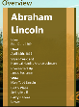 Conference Missouri Valley Conference
     3. President Alvin Bowman
     4. Students 12,000
     5. Location Normal Il
     6. Nickname Redbird
  5. **An RSS Feed for News about your subject** – This can be found on many different places. If its something like a school, most school sites have RSS Feeds on them. If not do a search for “Your subject here Rss news feed” and see what you find
     1. <http://feeds.illinoisstate.edu/rss/news/videtteonline/news.xml>
  6. **A URL for a main site that holds news information about your subject** (This is usually the place where you found the rss feed but not always)
     1. <http://illinoisstate.edu/>
  7. **Latitude and Longitude for Weather** This part of the app does not work for every subject. It will work for things like schools (what is the weather at the school, or vacation destinations, but does not work for people unless you use it for something like What is the weather at the Abraham Lincoln library)  
       
     You can find the latitude and longitude of any address by going to this site <http://www.latlong.net/>
     1. 40.512951 , -88.99334
  8. **A author or a search term for You Tube.** You will be pulling videos from you tube that work with your topic. You can either pull by key words OR by author. When you look for videos on YouTube you may come across one channel (author) that has the videos you want showed in your app. The author will be under the video like in the image below.  
       
     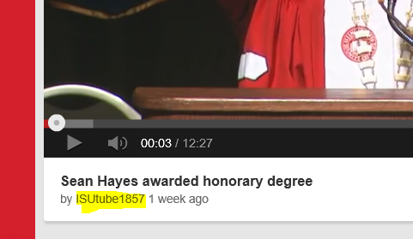  
       
     If you don’t find an author you like, you can just use a search term like Illinois State University.

You also need the plain URL for your subject, if it is an author it will look like this  
<http://www.youtube.com/user/ISUtube1857>  
if it is a search it will look like this  
http://www.youtube.com/results?search_query=Illinois+State+University

* 1. **Images needed for the Application** – You will need the following images for your application
     1. Logo.png – 150 x 150
     2. SmallLogo.png – 30 x 30
     3. StoreLogo.png - 50 x 50
     4. SplashScreen.png – 620 x 300
     5. Background.jpg -- Big.. At least 1024 x 760 ( Sizes you would normally use for wallpaper)
     6. SummaryImage.png – 350 x 350
     7. AltAdvert.jpg 640 x 512 (if you are using ads, this will show if the ads are not working… if you are not, you don’t need this)
        + 1. NOTE: The images you find will not already be these sizes, you will have to convert them to these sizes using Notepad or Paint.Net(or other photo manipulation software) Instructions on how to do this can be found in the appendix.

Do not steal images ☺ There are plenty out there under the creative commons license (cc). You can search on Bing, Google, Flicker, or check out the resources on Code Foster <http://codefoster.com/post/2012/11/20/media>

For the logos and the splash screen, try to find something that looks good on a white background, since this will look the best in the template. Make sure the image is big enough for the splash screen. It is easier to scale down than scale up. Also, as stated, look for an image that has a white background if all you have to modify the image with is paint (See Appendix)

[](http://www.google.com/imgres?hl=en&sa=X&biw=1536&bih=766&tbs=isz:lt,islt:xga&tbm=isch&tbnid=IRlouQKRBvpMyM:&imgrefurl=http://www.depaulbluedemons.com/sports/w-baskbl/spec-rel/121811aac.html&docid=3KuR30FnELUdpM&imgurl=http://grfx.cstv.com/photos/schools/depa/sports/genrel/auto_original/5879800.jpeg&w=1821&h=2113&ei=OWAxUbj4B8LuqAGN6YFY&zoom=1&ved=1t:3588,r:16,s:0,i:195&iact=rc&dur=1821&sig=109435870045470456393&page=1&tbnh=194&tbnw=164&start=0&ndsp=20&tx=88.4000244140625&ty=114.60003662109375)

When looking for the Background.jpg make sure, you are getting a large file. On Bing, make sure you select the “Wallpaper” size when searching; it is in the upper left hand corner.

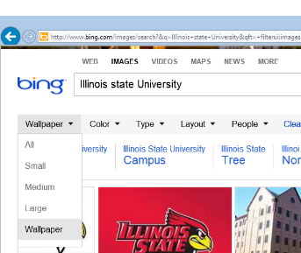

For Google, you will need to first Click on Search Tools and then Select a size greater than.

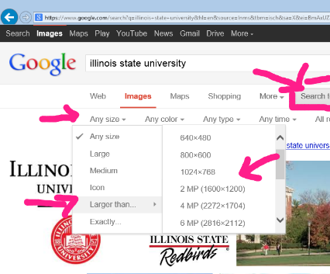

Since there are a few different ways to modify your images for the application, please see **Appendix 3:** Using Paint.Net to modify Images **OR Appendix 4:** Using Paint to modify images. Of course, if you are used to another program to do image editing, you may use that also.

That should be all the data you need for your application.

Exercise 3: Add your information to the template

1. For this section of the lab, you will need to use Visual Studio 2012. Make sure you unzipped the project from the zip file (Most likely called infohub.zip)

Task 1 – Get the project up and running

* 1. You will need Visual Studio 2012 Express for Windows 8 (its free) to develop for Windows 8  
     <http://www.microsoft.com/en-us/download/details.aspx?id=30664>
  2. You will also need the MS Advertising SDK --   
     You can download it at <http://go.microsoft.com/?linkid=9815330> Install it after after you install VS2012 Express
  3. These are extra steps you need to take if you don’t already have Windows 8
  4. If you don’t have a Windows 8 Machine, you can use a 90 day eval and create a BootToVHD   
     <http://blogs.technet.com/b/haroldwong/archive/2012/08/18/how-to-create-windows-8-vhd-for-boot-to-vhd-using-simple-easy-to-follow-steps.aspx>
  5. If you have a mac you can use bootcamp or VMWare Fusion  
     <http://www.intowindows.com/install-windows-8-on-mac/>   
       
     <http://blogs.technet.com/b/haroldwong/archive/2013/01/25/configuring-mac-for-windows-8-and-windows-phone-development-with-vmware-fusion-5-02-installing-and-configuring-part-1-of-3.aspx>
  6. Go to <http://w8templates.codeplex.com/SourceControl/BrowseLatest> and click on the Download link to download the template.  
       
     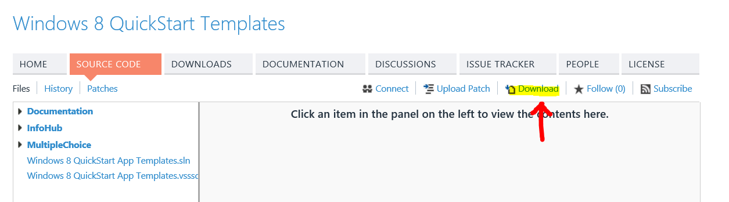
  7. Unzip the file w8templates-xxxx .
  8. Once unzipped you will see three folders and two files.   
       
     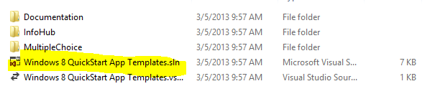  
       
     Note, there are two templates in the download. We will only be working with the InfoHub project in this document.
  9. Double click on the Windows 8 QuickStart App Template.sln to open the solution.
  10. You will get 3 dialog boxes that you don’t need to worry about  
        
      Click NO  
        
      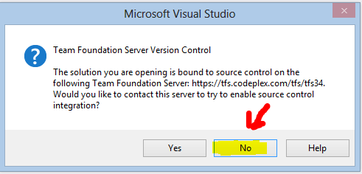  
        
      Click OK  
      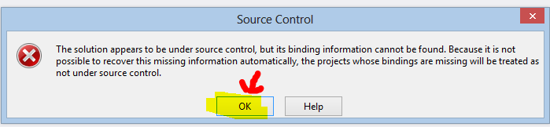  
        
      Click OK (Both times)  
        
      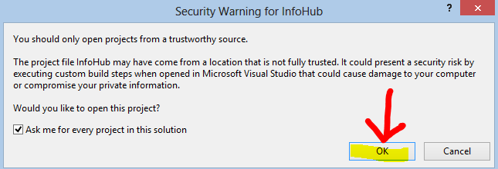
  11. Once the project opens up in visual studio we will need to clean and rebuild it. (this is sometimes needed because of being zipped)  
      Right click on the Project in the Solution Explorer (Not the solution) and select Clean.

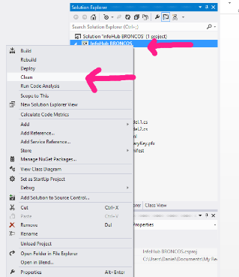

The output windows will show Clean: 1 succeeded

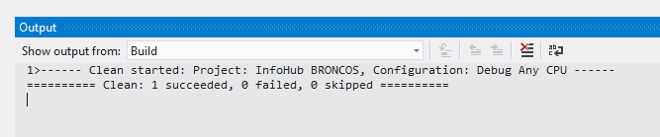

Repeat this process but instead of selecting Clean, select Rebuild

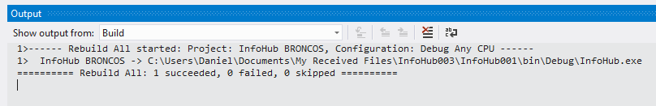

The output will show Rebuild All: 1 Succeeded

(You may have to do this twice)

Once this is completed, hit F5 on your keyboard to run the project. (Say yes to allow location) When the project runs, you should see the app for the Denver Broncos… confirm that it works, this is what we will be modifying for our own project.

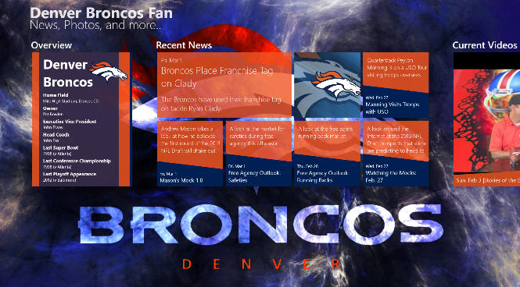

Task 2 – Modify the AppHubViewModel1.cs page

* 1. In the solution explorer, double click on the AppHubViewModel1.cs page (not 2) to open it in visual studio.  
     In this file you will see a “Strings Class”, this is where you will be modifying all the information.
  2. Change the **Title** and **Subtitle** to the titles you selected in exercise 1.

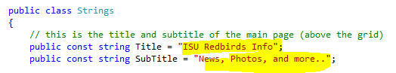

* 1. The next section is the information that you got from Wikipedia… add the Wikipedia link to the SummaryMoreUrl.  
     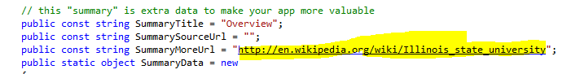
  2. Next add the summary data that we collected from Wikipedia (Keep the top two lines short)  
       
     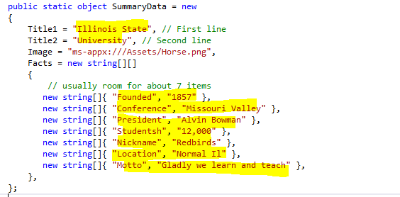  
     If you have fewer than 7 items, delete the **new string[]** lines you are not using
  3. Next, add the RSS feed you found for the news for your subject.  
       
     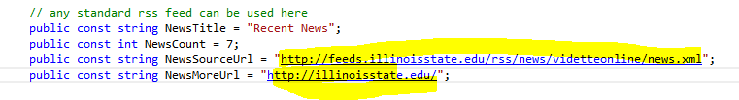
  4. If you were able to find a ics calendar that has something to do with your subject, put that information next.  
       
     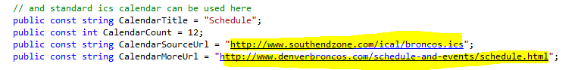  
     NOTE: If you did not find ICS calendar information, we will need to comment this section out. To do this :  
     Change CalendarInclude to false

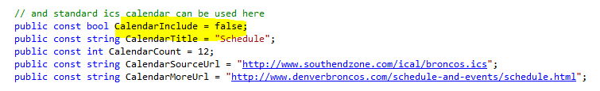  
You can repeat this for ANY of the sections you want to comment out and not use…. Weather would be another one you may not use in your application.

* 1. Now add the search term for the Flickr pull  
       
     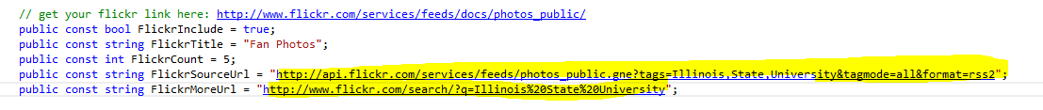  
     if it is multiple words, separate them with a comma on top and a %20 on bottom. Be careful not to change anything else in the line.
  2. Now add your keywords to twitter  
       
     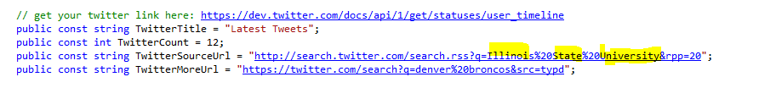  
       
     Notice that the keywords are separated by %20… again, be careful editing this line.
  3. Next we will add the Latitude and Longitude that we collected to the weather pull. (Remember, this does not make sense for every app, if it does not make sense for your app, comment it out like shown above in number 6.)  
       
     
  4. After that we will add our search for YouTube. Remember there are two ways to do this, by author or by search. If you found a video author you like it will look like this  
       
     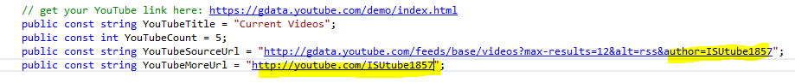  
     If you are doing a plain search it will look like this  
     

Notice that the word author was changed to q

* 1. Now you need to add a privacy statement. There is an example one you can find in the PrivicayUrl string. If you don’t have a website to host one on, you can use the generic one.  
     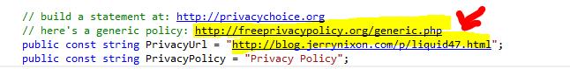

**SECOND OPTION:** If you would like to use a local privacy policy OR if your app is failing submission in the store due to Privacy Policy. Change PrivacyPolicyUseLocal to True and add your contact email.

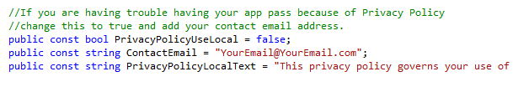

* 1. To allow people to share information from your application, you need to change this text to something that works for your app.  
       
     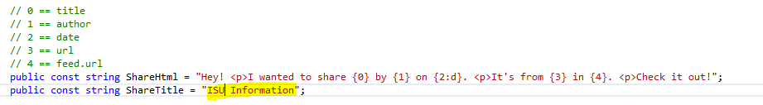
  2. If you have the time, you can put ads in your application. See the appendix for how to do this. If you don’t have time, just set the IncludeAdvertising to false.  
       
     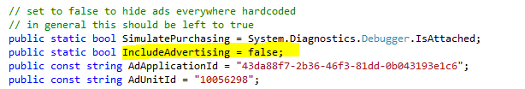
  3. Finally we want to change the primary and secondary colors (unless the blue and orange go with your theme. Open up the Styles folder in the solutions folder and double click on Shared.xaml  
       
     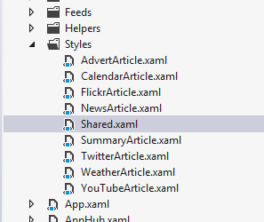  
       
     In here you will find the colors that come with the template  
       
     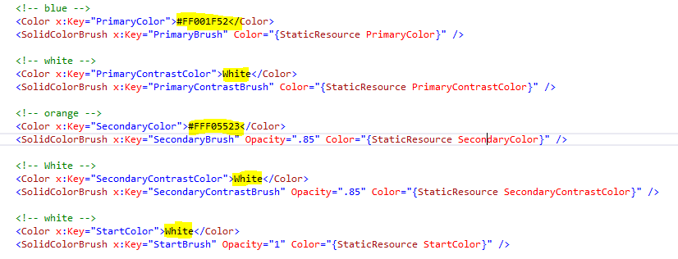

You can either use a standard color like White or Blue or use its color code to change it. In addition you can use the color picker that is shown when you over over any of the static resources. (color picker will be shown if you click on the green square and select edit resource)  
  
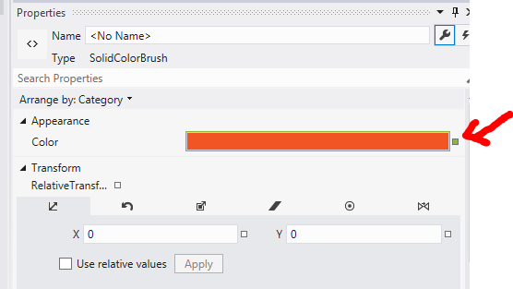

* 1. Now, you want to copy the images you created to the Assets Folder.
  2. Finally, open up the Package.appmanifest file and Change the Displayname and Publisher Displayname to your name and app name  
       
     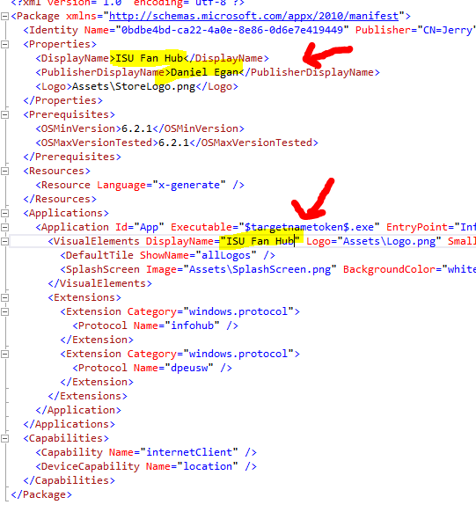

Exercise 4: Upload your application to the Windows Store

Once you have completed your application you will want to upload your application to the Windows Store. In this section, we will assume that you already have a Windows Store account and that you have already signed into <http://dev.windows.com> . If you need to create and account, or sign up for dreamspark, please see the appendix. We will also not be telling you what everything you will see means. We will only be covering the steps you need to take. If you need more information you can find it here. <http://msdn.microsoft.com/en-us/library/windows/apps/br230835.aspx>

Since this template has been tested to work with the windows store, all we need to do is to:

* Create a package to upload to the store
* Reserve a name for our application
* Upload our package
* Fill out remaining information

1. In Visual Studio, right click on your solution and select **“Store”** and then select **“Create App packages” .** Once your package is created you will find a new folder called **“AppPackages”** inside your application folder. Inside the “AppPackages” folder is a file that ends with **“.appxupload”** extension. This is the file you specify when you upload your app.

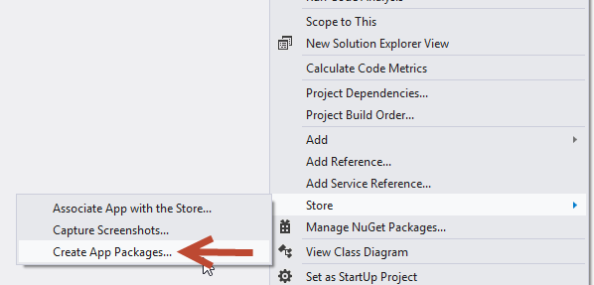

1. Leave Yes checked and Click the Sign in button

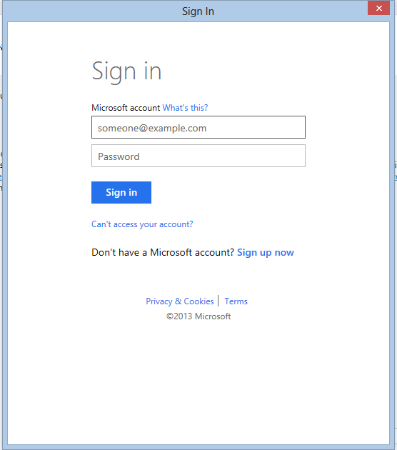

1. Sign in using the liveID that you used when you created your Microsoft Store account.

Click on Reserve Name to reserve the name you want for your application.

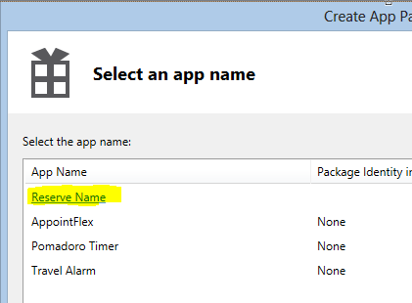

1. A browser window will pop up that will take you to the dashboard section of the dev center and will ask you to give your application a name (if you are not signed in, it may ask you to do that again)

Click on App Name

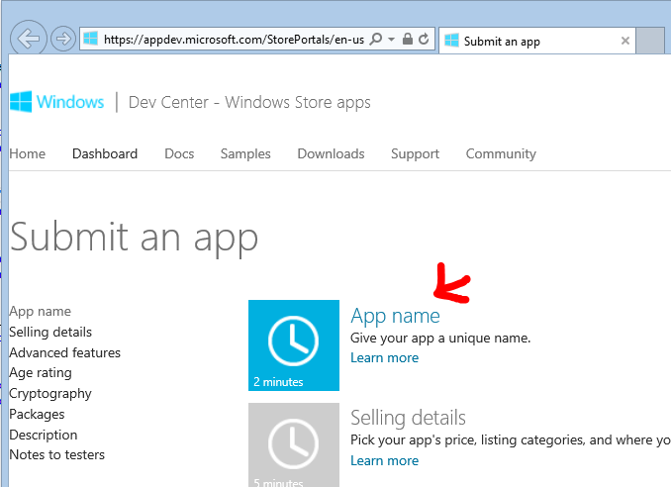

1. Add your App Name and select Reserve app name

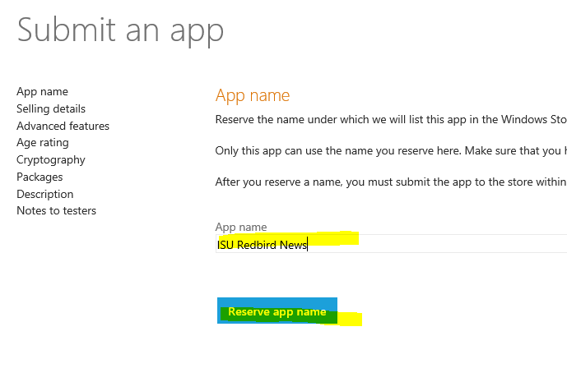

1. If the name is available, it will tell you, if not find a name that is available. When done click Save. (AND leave this browser window open)

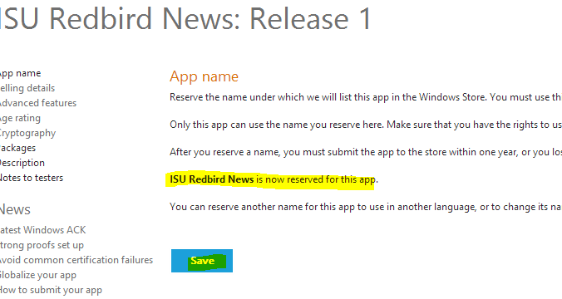

1. When you go back to Visual Studio the App List will start updating.

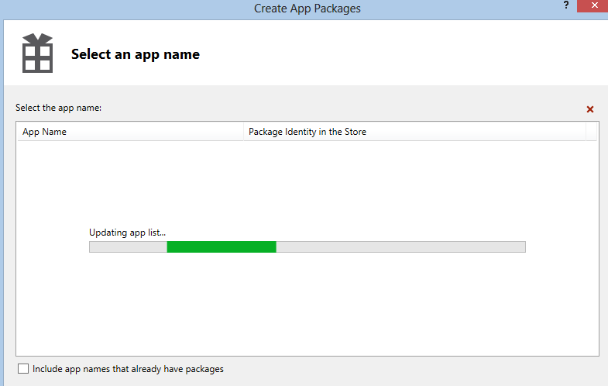

1. When it refreshes, select your app from the list and click on next.

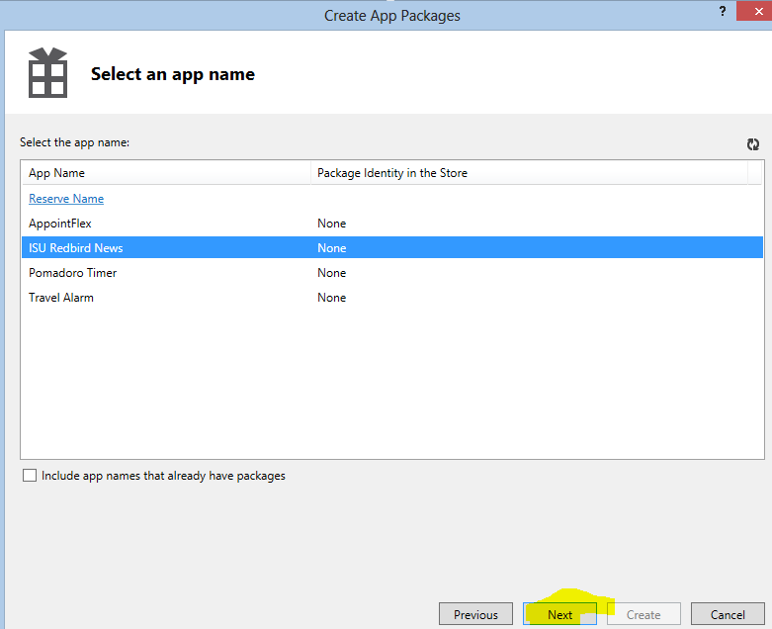

1. On the next screen leave everything as it is and click on Create

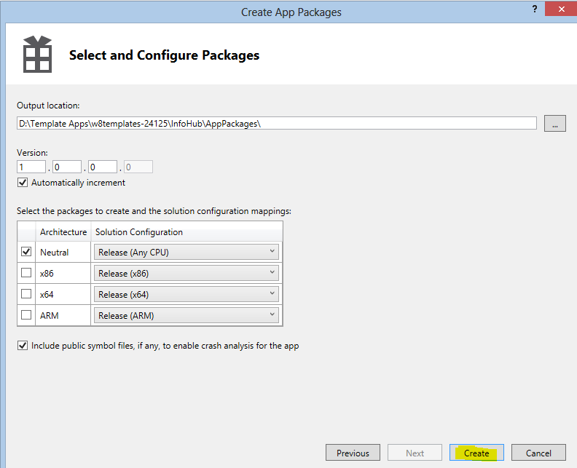

1. When it is done, it will give you a link to your package.

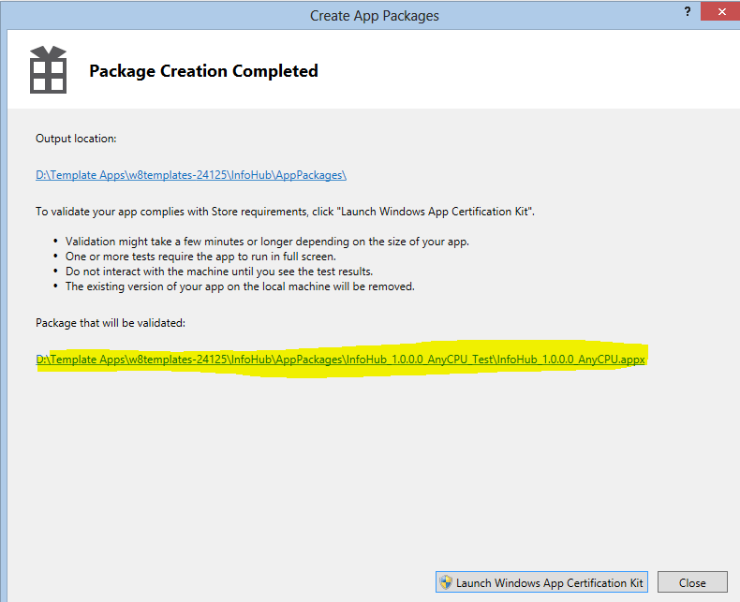

* 1. Leave this up; you will need this for the next step.

1. Now open back up the browser window where you reserved the App Name. You will notice that App Name is “Complete” but others in the list still need to be done. We will go through these one by one

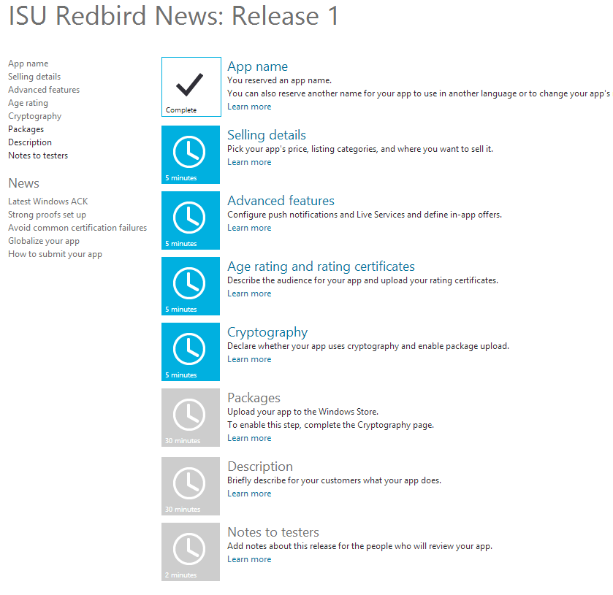

1. Click on Selling details  
    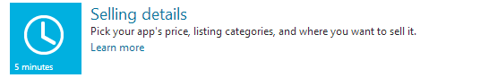

Select “Free” from the Price tier dropdown  
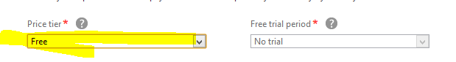

Scroll to the bottom and click the United State Checkbox

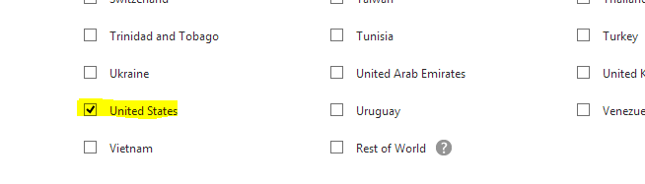

Scroll down to Category and select the category that fits

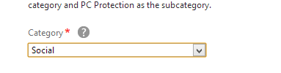

Then just click Save

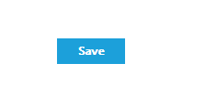

1. Next Click on Advance Features

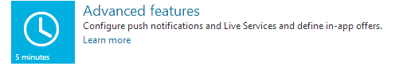

Just Click Save to exit



1. Click on Age rating and rating certificates

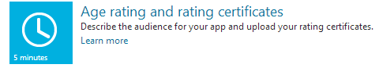

Select the 12+ Radio Button

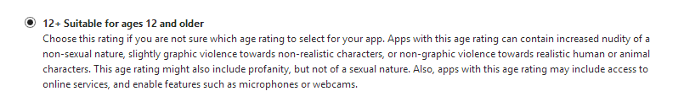

Scroll down and click on Save



1. Click on Cryptography  
   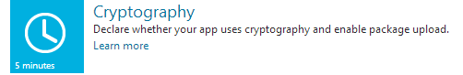

Select NO, Check the Box and Click Save

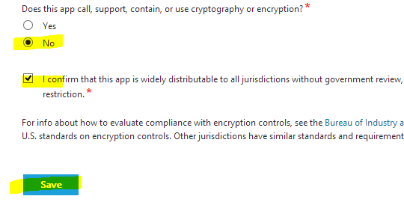

1. Now you can upload the package you created earlier. Click on Packages

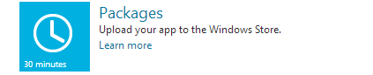

Click on the link that Visual Studio Gave you earlier to see the package you created.

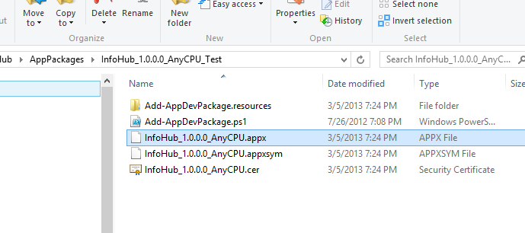

Drag the .appx file to the Packages Window.

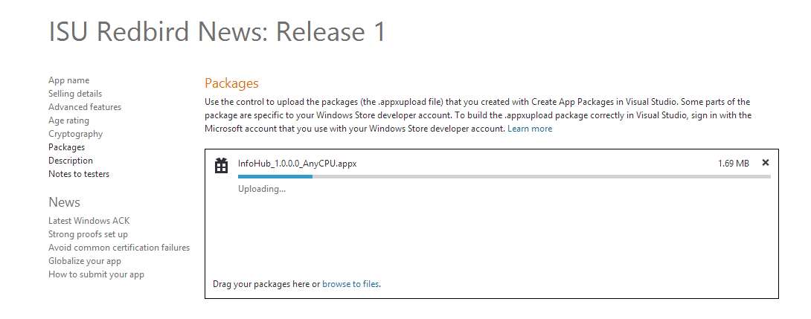

When it is done, it will show success. Click on Save

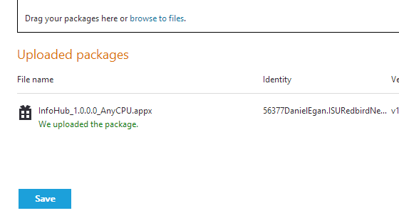

1. Next Click on Description

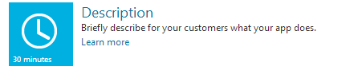

Fill in all the items with the Red Asterisk 

Description

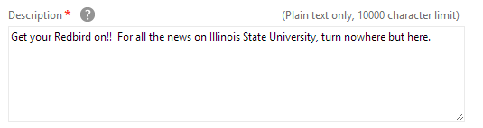

Copyright (just add your name instead of ChicagoIslandGroup

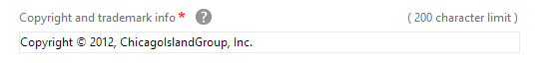

Add at least one screenshot.

* 1. (See **Appendix 5:** How to take a screenshot of your app)
  2. **NOTE**: If the Image is too big (2MB or over) it wont upload (move the screen around until you get one that is smaller than 2MB. Otherwise you will need to edit it in paint to make it smaller.

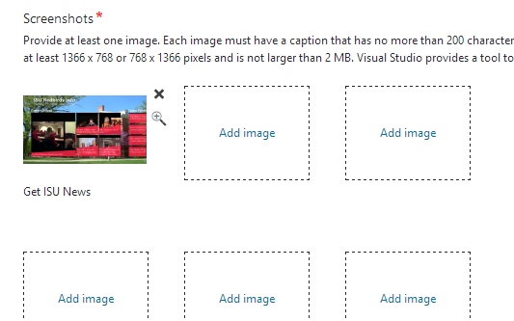

Add the Support Contact Info (They email that users can contact you at)  
AND the a link to your online Privacy Policy  
 and then click on Save

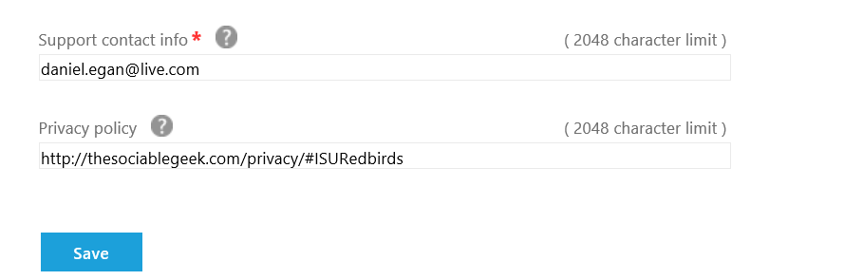

1. Click on Notes to testers.

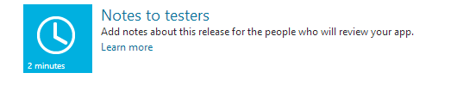

We don’t need anything here so just hit save.



1. That is the last one. Now just click on Submit for certification

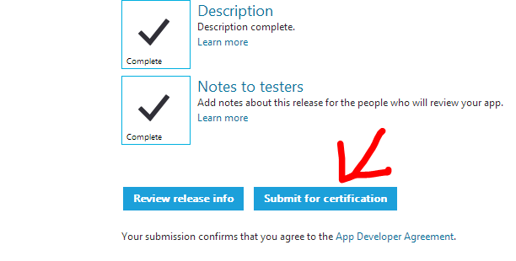

Appendix

In this section, you fill find stuff that you MAY have to do, including Sign up for Dreamspark, Edit images and more. I put them in Appendix in case they were needed.

Appendix 1: Sign up for Dreamspark

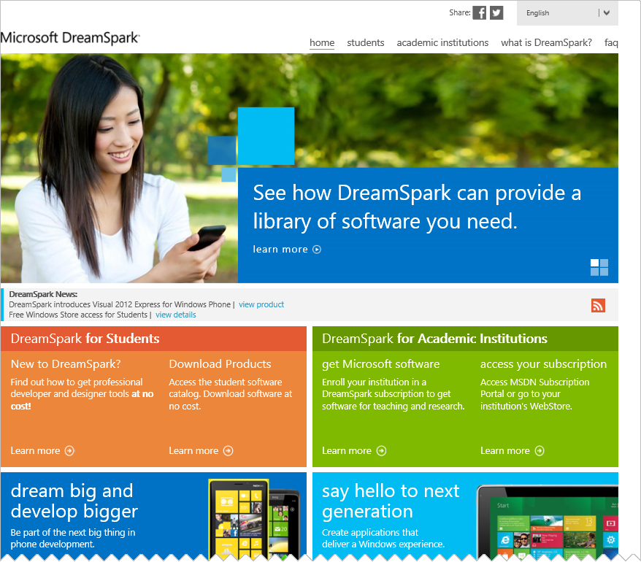

Appendix 2: Sign up for the Windows Store

Coming Soon

Appendix 3: Using Paint.Net to modify Images

Once you have downloaded the images you will need to make them the correct size. As state above, at a minimum you will need the following sizes.

* + 1. Logo.png – 150 x 150
    2. SmallLogo.png – 30 x 30
    3. StoreLogo.png - 50 x 50
    4. SplashScreen.png – 620 x 300
    5. SummaryImage.png – 350 x 350
    6. Background.jpg (at least 1024 x 768) You should not need to modify this one.

Since making the images will be the same process except for the size, I will only show you how to to do one of the images, Logo.png.   
The image I have selected for the items above is Reggie the Redbird.

[](http://www.google.com/imgres?hl=en&sa=X&biw=1536&bih=766&tbs=isz:lt,islt:xga&tbm=isch&tbnid=IRlouQKRBvpMyM:&imgrefurl=http://www.depaulbluedemons.com/sports/w-baskbl/spec-rel/121811aac.html&docid=3KuR30FnELUdpM&imgurl=http://grfx.cstv.com/photos/schools/depa/sports/genrel/auto_original/5879800.jpeg&w=1821&h=2113&ei=OWAxUbj4B8LuqAGN6YFY&zoom=1&ved=1t:3588,r:16,s:0,i:195&iact=rc&dur=1821&sig=109435870045470456393&page=1&tbnh=194&tbnw=164&start=0&ndsp=20&tx=88.4000244140625&ty=114.60003662109375)

1. The first thing you want to do is to open the image in paint. Right click on the image in the file system and select Open With 🡪 Paint.Net (not Paint).  
   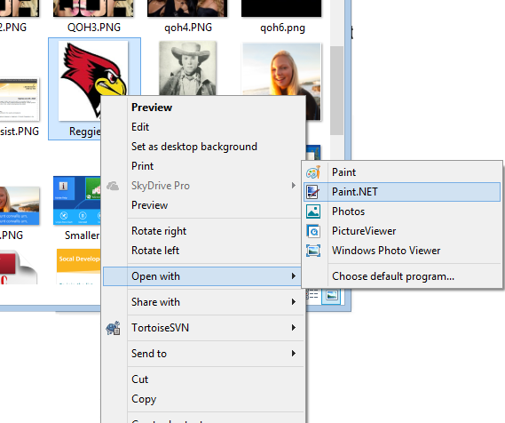  
   This will open up the image in Paint.Net  
     
   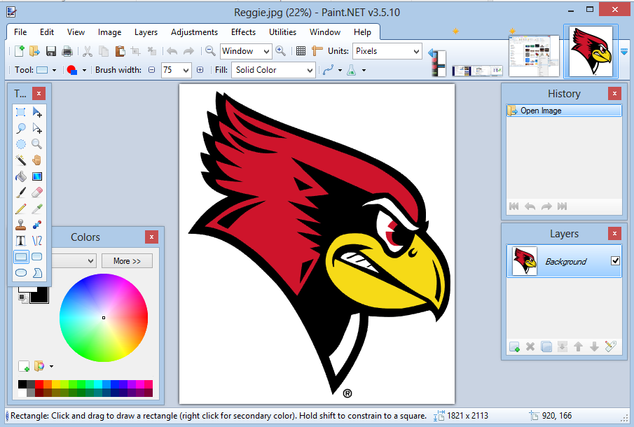
2. For the Logo.png, we need it to be 150 x 150 so we select Image 🡪 Resize from the Menu. When you do this the Resize dialog will pop up.   
   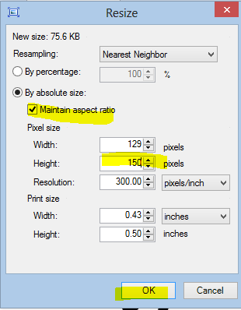
3. You might think you can change this to 150 x 150 and be done… but you cannot. If you do that it will change the way the image looks, and we don’t want that. What we need to do is to change the BIGGEST number (either horizontal OR vertical, whichever is bigger) to 150, making sure the Maintain aspect ratio box is checked.   
     
   Once you have done this, click OK
4. Next click on Image 🡪 **Resize Canvas** . This will bring up the Canvas Size dialog box up.   
   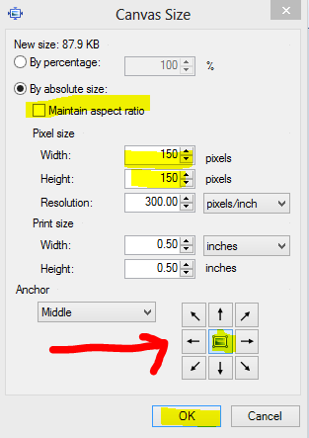
5. UNCHECK the Maintain aspect ratio checkbox and make the width and height both 150. Make sure you set the Anchor on the bottom to the center, so it centers your image in the middle of the canvas.

This will leave you with black lines on either side of your image (or on top and bottom). There are a couple of ways to remove them.

1. In the tool box, click on the bucket icon and make sure that your color is set to White  
   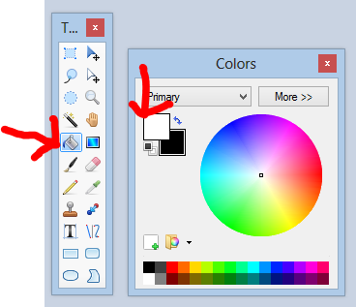
2. With the bucket selected, click with your mouse on the black portion of the image. This will remove the black line. Do this for both sides  
   
3. When you are done, go to File 🡪 Save As and save your image as a png (In this case Logo.png)
4. One last thing you may need on some of your images is to have NO background (instead of white)   
   To do this click on the magic wand icon in the toolbox   
   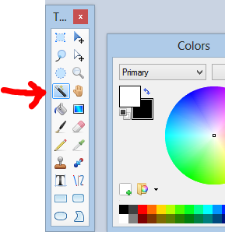
5. Now click on the white portion of your image (in the case of the image we are using in this tutorial)  
   This will highlight everything White
6. Next hit Ctrl-X on your keyboard this will remove the background from around your image.

 

1. You can now save this image as a .png without the background.

Appendix 4: Using Paint to modify images

Paint is a very limited tool but will work for our images if needed in a pinch. I still would recommend getting Paint.Net (Free) <http://GetPaint.Net> (See Above) for your image manipulation because you will have more freedom and its Free.

Once you have downloaded the images you will need to make them the correct size. As state above, at a minimum you will need the following sizes.

* + 1. Logo.png – 150 x 150
    2. SmallLogo.png – 30 x 30
    3. StoreLogo.png - 50 x 50
    4. SplashScreen.png – 620 x 300
    5. SummaryImage.png – 350 x 350
    6. Background.jpg (at least 1024 x 768) You should not need to modify this one.

Since making the images will be the same process except for the size, I will only show you how to to do one of the images, Logo.png.   
The image I have selected for the items above is Reggie the Redbird.

[](http://www.google.com/imgres?hl=en&sa=X&biw=1536&bih=766&tbs=isz:lt,islt:xga&tbm=isch&tbnid=IRlouQKRBvpMyM:&imgrefurl=http://www.depaulbluedemons.com/sports/w-baskbl/spec-rel/121811aac.html&docid=3KuR30FnELUdpM&imgurl=http://grfx.cstv.com/photos/schools/depa/sports/genrel/auto_original/5879800.jpeg&w=1821&h=2113&ei=OWAxUbj4B8LuqAGN6YFY&zoom=1&ved=1t:3588,r:16,s:0,i:195&iact=rc&dur=1821&sig=109435870045470456393&page=1&tbnh=194&tbnw=164&start=0&ndsp=20&tx=88.4000244140625&ty=114.60003662109375)

1. The first thing you want to do is to open the image in paint. Right click on the image in the file system and select Open With 🡪 Paint.  
     
   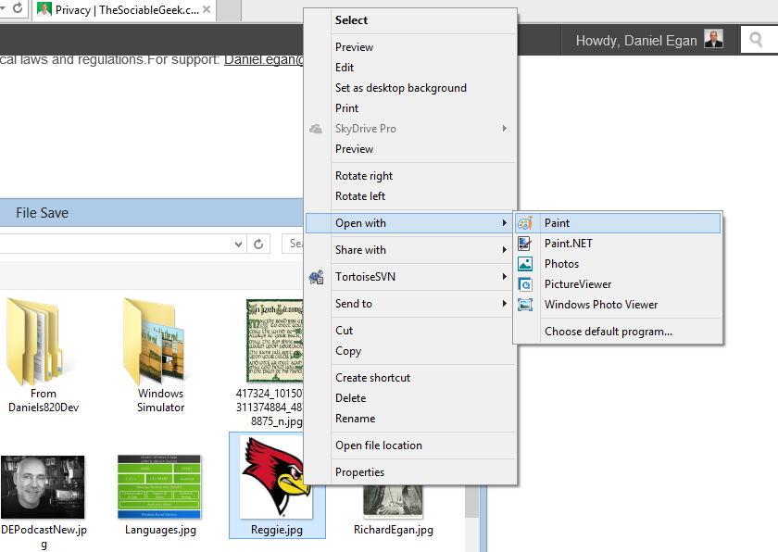
2. As discussed above, you should select an image that is larger than you need it. As you can see when I open Reggie.jpg in Paint it is huge… 1821 x 2113 to be exact (as shown on bottom of image below)  
     
   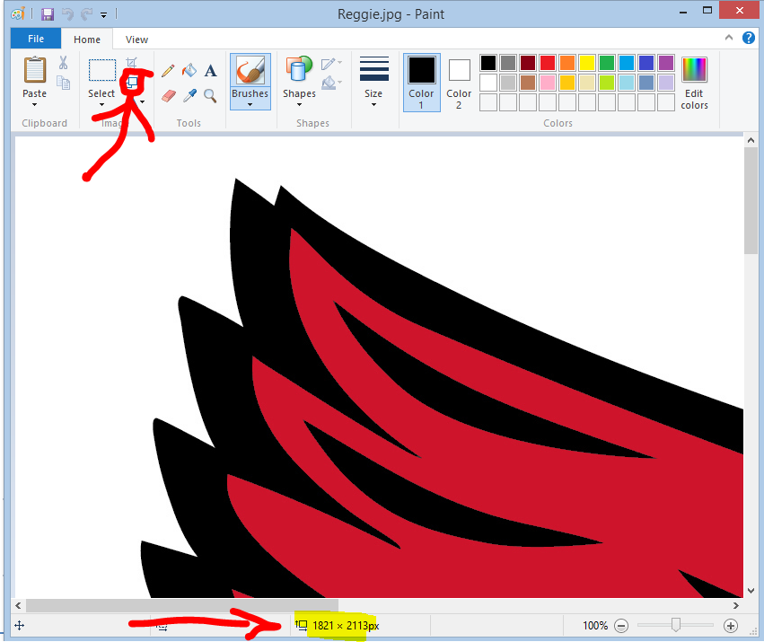
3. For the Logo.png, we need it to be 150 x 150 so we select the Resize Icon as shown above. When you do this the Resize and Skew dialog will pop up. The first thing we need to do is change the radial button selected from “Percentage” to “Pixels”  
   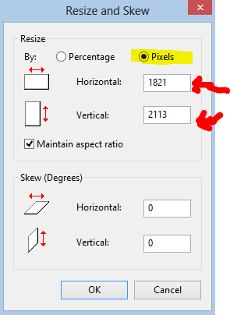
4. You might think you can change this to 150 x 150 and be done… but you cannot. If you do that it will change the way the image looks, and we don’t want that. What we need to do is to change the BIGGEST number (either horizontal OR vertical, whichever is bigger) to 150, making sure the Maintain aspect ratio box is checked.   
     
   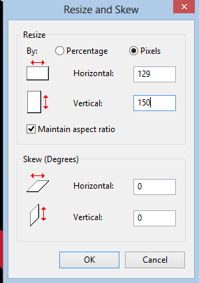
5. Once you have done this, click OK  
     
   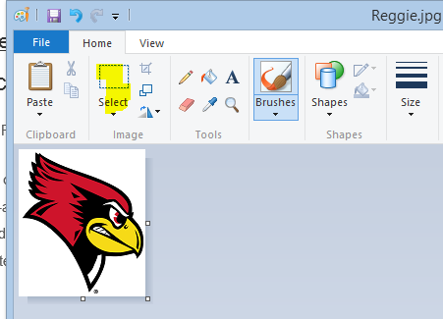
6. Once you have done this, you will be almost there. The size we need is 150 x 150 but this is 129 x 150 so we need to fix that.
7. Click on the select tool and use it to select the whole image  
     
   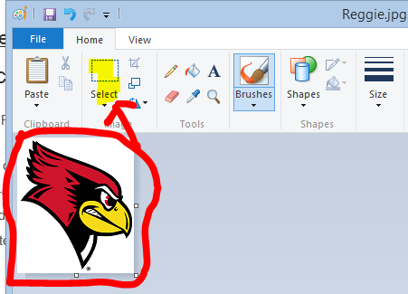
8. Once you have done this, click on the copy icon (or hit ctrl-C)  
     
   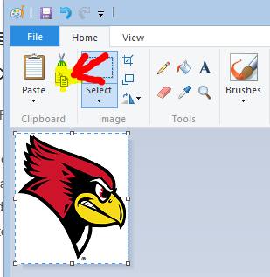
9. Once you are sure you copied it, go to **File 🡪 New** to create a new image. When it asks you if you want to save it select Don’t Save (because you should already have it on the clipboard from the last step)
10. It will create a blank image the same size as the last one.. we need it 150x 150. So click on the resize icon again, click on Pixels, uncheck “Maintain aspect ratio” and change the size to 150 x 150 then click OK  
    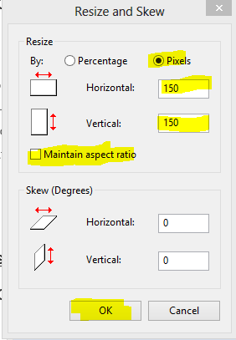
11. Click on the paste icon (the big clipboard) and move your image to the center. When you are done, it should look something like this.   
      
    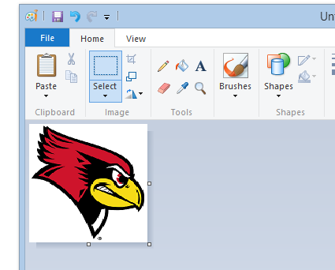
12. Select File 🡪 Save As 🡪 PNG File to save your image (This one is called Logo.png)  
    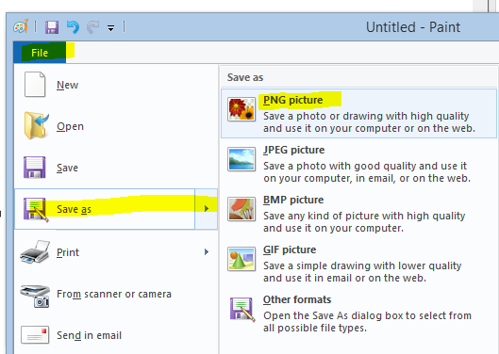
13. Repeat these steps for all the images you need.

Appendix 5: How to take a screenshot of your app

To take a screenshot of your application, you will need to run the application in the simulator. To do this, select simulator from the dropdown on the top of Visual Studio.

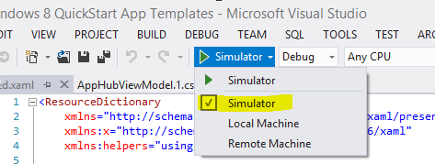

When done, hit F5 to run your application

It will now be running in the simulator. Make sure that it is simulating 1366 x 768

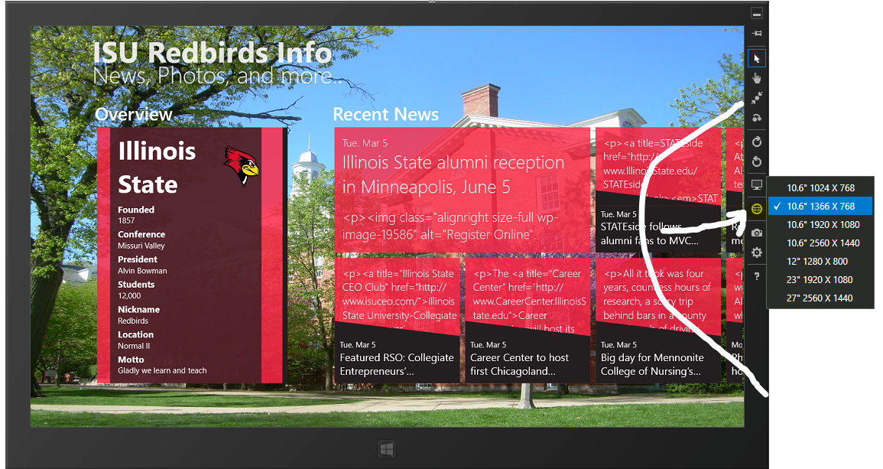

Next, click on the camera to take a screenshot

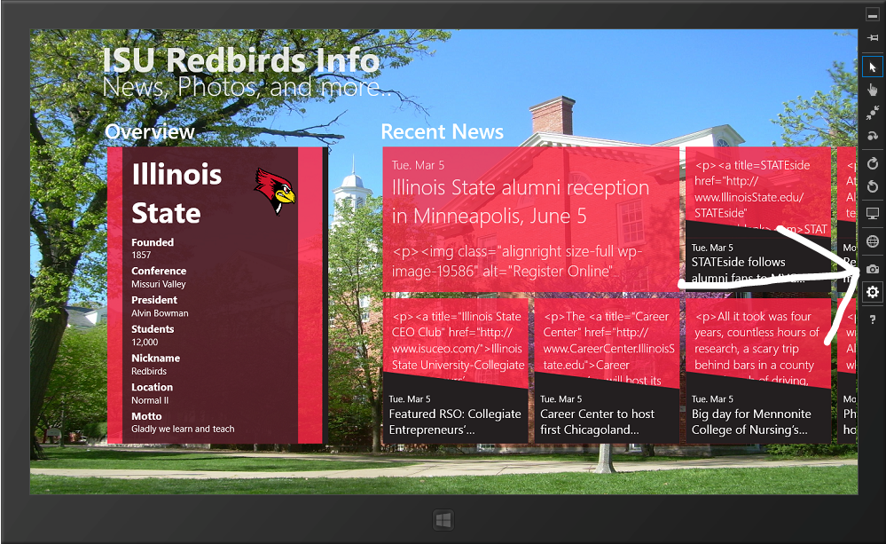

To see where it is saving your screenshots click on the settings icon.

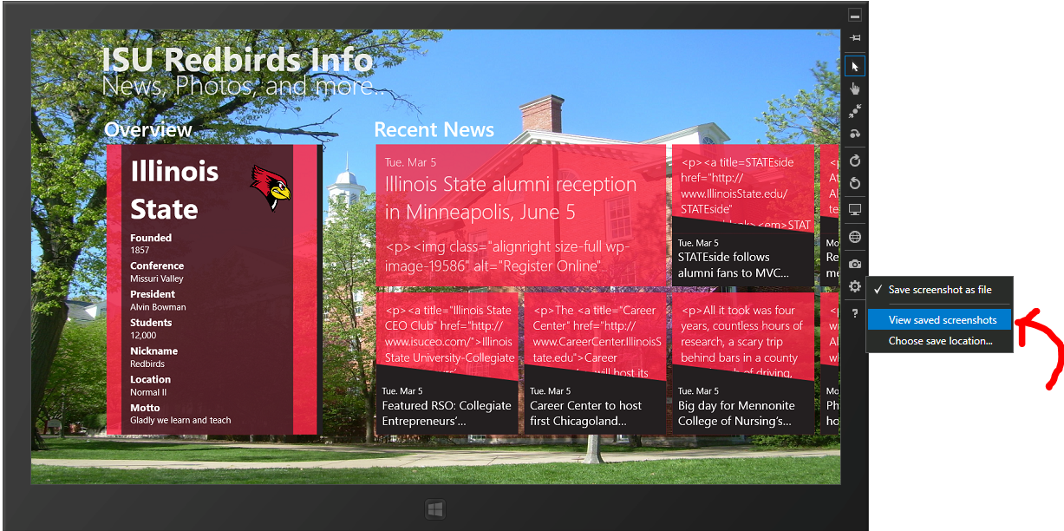

Note the location, you will need this when submitting to store.

Appendix 6: How to resubmit your app to the store if it fails

Since we wont specificlly know “WHY” your app failed certification, in this section we are assuming that you already fixed what failed and created a new app package by going to Store 🡪Create App Package



Once you have re-created your app package, sign on to your dashboard at <http://Dev.Windows.Com> (click on dashboard). You will see the app that failed on top. Click on the Edit link.

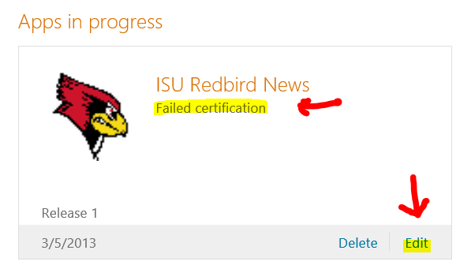

After looking at what failed, click on Edit Release

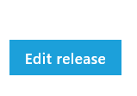

All the boxes should still be checked. We just need to edit the Package. So click on Packages

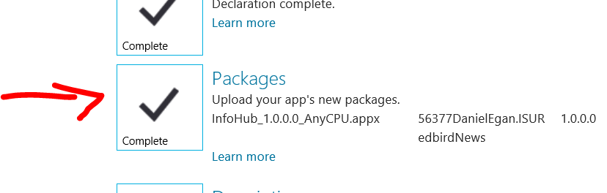

Now we need the new package.

Click on the link that Visual Studio Gave you earlier to see the package you created.



Drag the .appx file to the Packages Window.



When it is done, it will show success. Click on Save

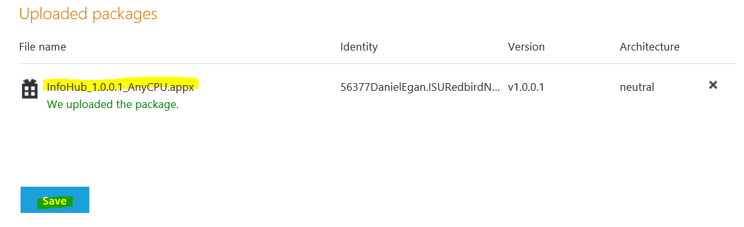

The only other thing you MAY want to do is add a note for the testers. Either way, when you are done click on Submit for certification.

